TMT/ Sangli/S0797/2026 09.06.2026
To,
Vitthaltambe Tambe,
Sangli, MH
Mobile: +91-9370768556

Dear sir,

Sub: - SUPPLY OF ROOFING PROFILE ROLL FORMING MACHINE
Thank you very much for your enquiry regarding your requirement of roll forming machine mainly for Color Coated Sections. We are glad to inform you that we would be in a position to supply you the required equipment. Given below are the required specifications and description of the machine and our terms and conditions.

Prices
The cost of Roll forming machine with roofing profile tooling along with De Coiler, Entry guide, Main Roll Forming Machine, Side Guides, Drive System, Cutting Unit and Cutting Die Sets for Rs 23,00,000/- (Rupees Twenty-Three Lakhs Only)
LIST OT EQUIPMENT
- HYDRAULIC DE-COILER, 4 MT CAPACITY
- ROLL FORMING MACHINE WITH 18 PASSES
- EN 31 ROOFING PROFILE ROLLERS DIE SET
- 10 HP DRIVE WITH GEAR BOXE
- COMPLETE ELECTRICALS ALONG WITH AUTOMATION – PLC
- CUTOFF ALONG WITH CUTTING TOOL

Technical specifications:

Maximum sheet width that can be formed | : 1300 MM
Maximum sheet thickness in MS that can be formed | : 0.6 MM
Minimum sheet thickness in MS that can be formed | : 0.36 MM
Roll shaft diameter | : ø 70 MM
The vertical distance between shafts | : 330 MM
The horizontal distance between shafts | : 550 MM
Number of forming stations | : 18 No’s
Drive (AC) | : 10HP
Speed of the machine | : 0-12 meters/max
Description of the equipment

Roll Forming Machine

Main Base
The main base is MS fabricated structure and adequately ribbed to minimize the distortion. It is accurately machined on top and bottom surfaces the threaded holes are made on the bed for positioning the stands.

Entry Guide
The entry side of the machine will be equipped with guide table and the guide bar which will be responsible for centering the leading ends of the strip into the first pass.

Mill stands

The stands are mounted on the bed of the machine the line alignment can be easily done due to threaded holes arranged on the bed of the machine. Each forming head consists of a fixed housing and sliding type out board housing. The mill stands will be arranged to locate shafts mounted on anti-friction bearings. For the top shafts the bearings are housed in the cartridge type bearing blocks. The bottom shaft bearings are located in the bored machined in the housings. The bottom arbors are fixed in position whereas the top arbors along with cartridge blocks could be raised or lowered in vertical guides machined in housings.

Roll shafts
The roll shafts will be manufactured from quality steel and will be keyed to locate tooling.

Drive
The drive to the roll former will be by means of a gear box system. The main drive will be provided by means of 10 HP motor. The speed of the roll former is variable.

Cutoff unit
The cutoff unit with hydraulic press along with cutting die set will be placed in the machine delivery side. The power pack motor is 5 HP
Die rolls : EN31 grade

GENERAL TERMS & CONDITIONS:
- Price quoted per unit ex-work. Hyderabad.
- Following charges are additional to your account.
  - Freight Charge : As actual to be borne by you.
  - Excise : Extra As Applicable
  - Sales Tax : Extra as applicable
  - Packing charge : As actual to be borne by you.
  - Insurance : As actual to be borne by you.
- Payment : 75% advance along with order balance before delivery but after inspection at our works.
- Delivery : with 75% advance 2 months / With 50% advance 3 months / With 30% - 4 months from date of advance received
- Validity : One month from the date of submission.
- Inspection : Inspection at our works prior to dispatch.
- Warranty : The machine is warranted for a period of 12 months from the date of dispatch against any manufacturing defects/ faulty material or bad workmanship of any part or component but not against any kind of abnormal or improper use of machine. Defective part or component will be replaced or repaired free of cost. Electrical components are outside the scope of this warranty.
- Commissioning : Erection & commissioning done by you, but required technical support & guidance provide by us at additional cost.

NOTE:
- Oil is not in scope of our supply.
- Raw material for trial is to be arranged by you at your cost.
We are sure you will find our offer in line with your requirements. Should you require any further clarification please contact me on mobile no.9246221106.
Thanking you and assuring you of our best services at all times.

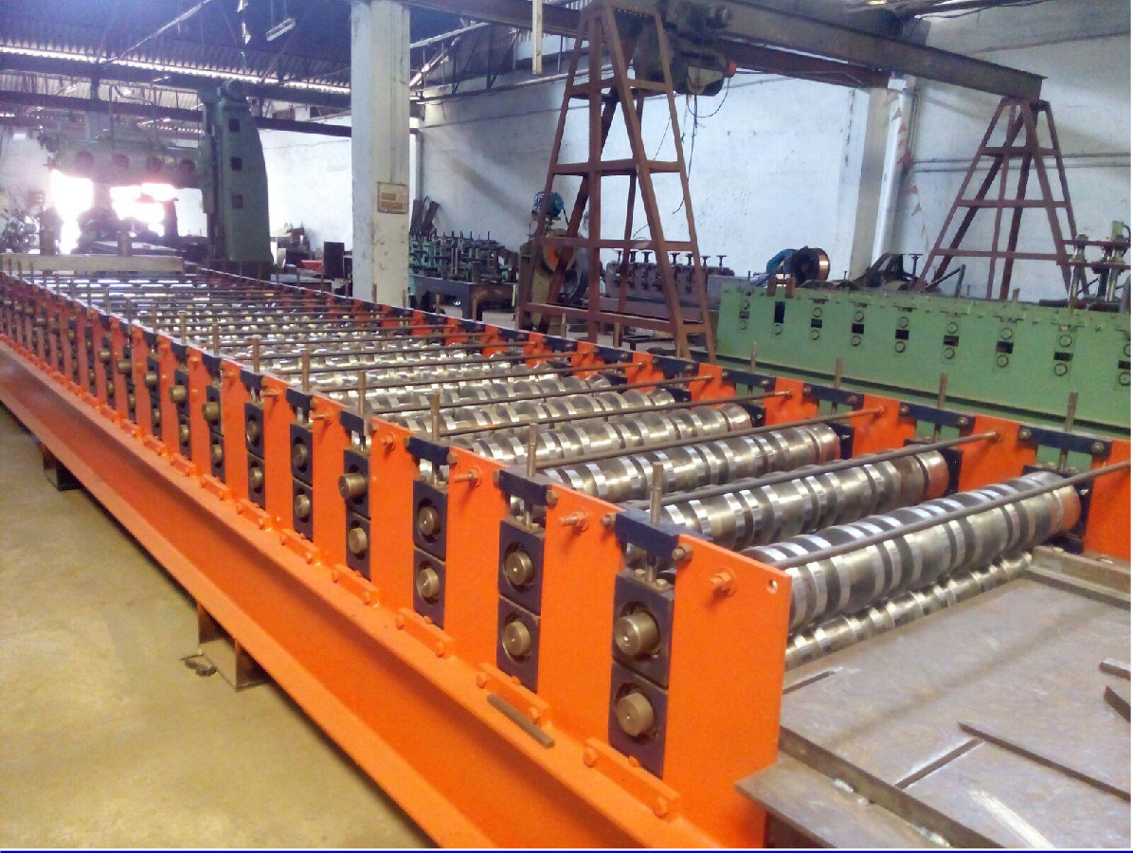

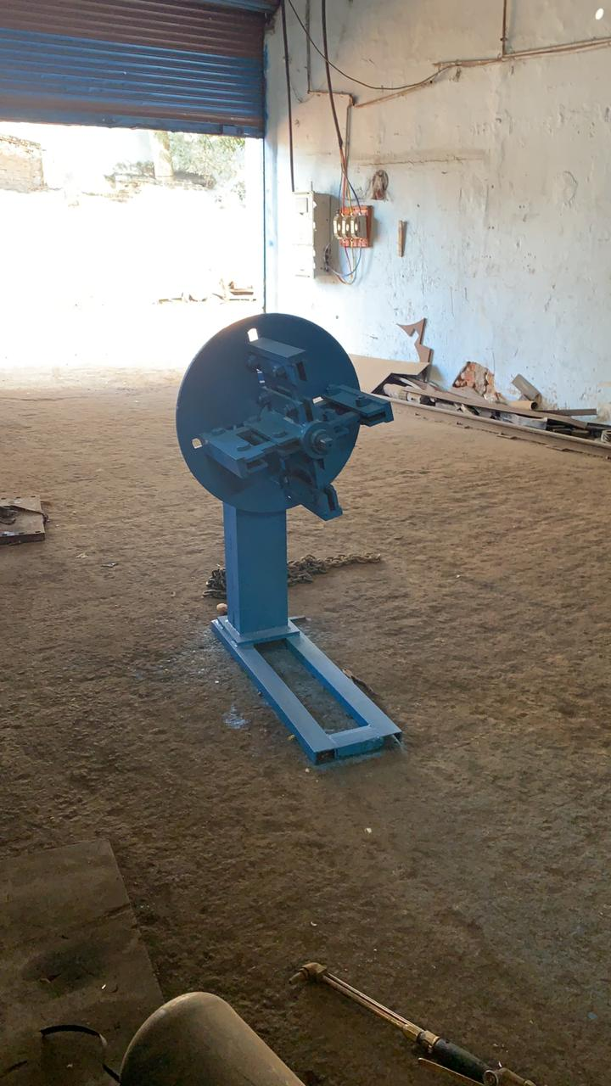

For Techno Machine Tools (T.SIVARAMAKRISHNA).

